Awais Afridi 876741 PISE

Q1: For each case, choose the condition that characterizes demand:

elastic demand, inelastic demand, or unit-elastic demand.

a) Total revenue decreases when price increases.

*Since Total Revenue is equal to the product of Price and Quantity Trade (P×Qd) so when Demand is Elastic -> The Quantity demanded dominates the Price effect and a slight change in Price will greatly effect Quantity trade so a little increase in Price in this case will greatly decrease the amount of Quantity traded and so total revenue will decrease as a result of less Qd, since consumer are very responsive to price change, this is the case of Elastic demand curve.*

b) The additional revenue generated by an increase in quantity sold is exactly offset by revenue lost from the fall in price received per unit.

*It is the case of Unit Elastic Demand: There is no increase or decrease in revenue. As percentage change in Price is exactly at same proportionate to the percentage change in Quantity demanded.*

c) Total revenue falls when output increases.

*It is the case when the producers tend to increase its Qd but on the other side it results in a large increase in price, due to which total revenue falls – the case of inelastic demand curve.*

d) Producers in an industry find they can increase their total revenues by coordinating a reduction in industry output.

*Reduction in industry output could be the possible effect of increase in price and so Qd will decrease - the case of Elastic demand curve; and producers find increase in total revenue.*

Q2: True or false?

When supply is perfectly inelastic, changes in demand have no effect on price. Please, explain.

When supply is perfectly inelastic, it means increase in price causes no change in Quantity supplied, a same amount of quantity will be available at higher price if demand increases. So it means if demand changes it will change price. The sentence above is wrong.

Q3: The market demand for diesel fuel is Qd=10-0.5P and the market supply is Qs=P-2.

a) Define the equilibrium price and quantity in the market for diesel fuel.

b) Calculate the price [elasticity](https://moodle.unive.it/mod/resource/view.php?id=39717) of supply and the price [elasticity](https://moodle.unive.it/mod/resource/view.php?id=39717) of demand in equilibrium. Are they elastic or inelastic?

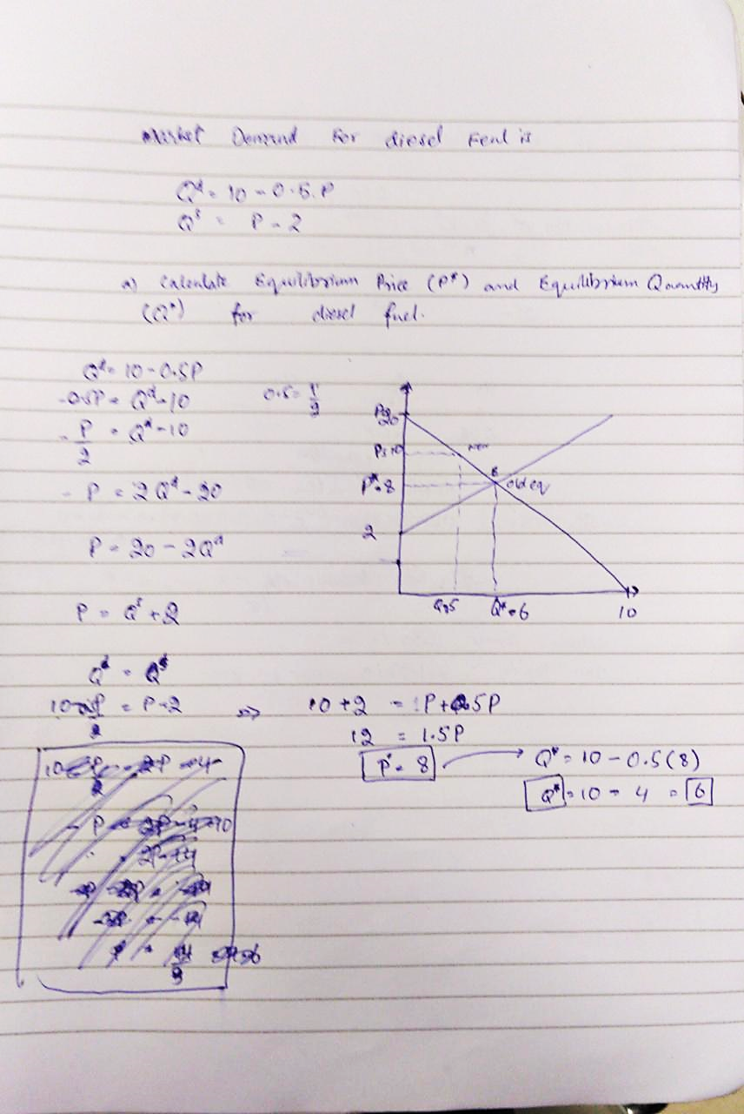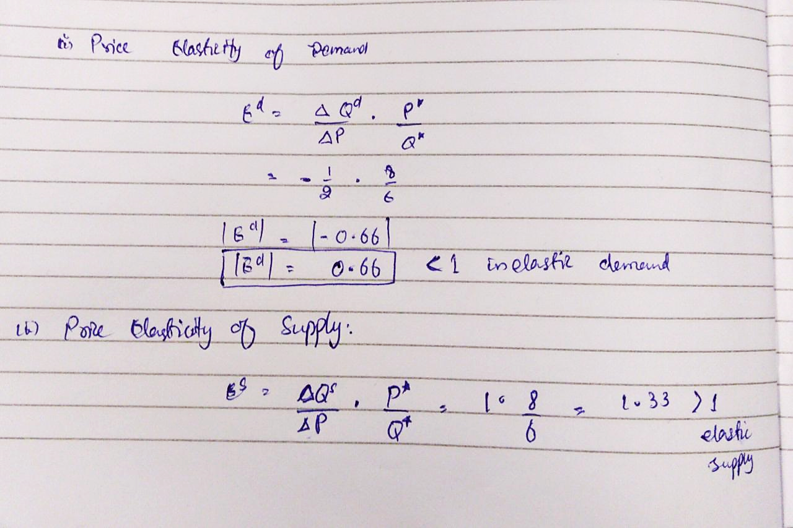

7

c) Now suppose that the Government introduces an excise tax of 3 euro per liter of diesel fuel bought.

Define the new quantity of equilibrium, the new price paid by buyers (Pb), the new price received by sellers (Ps). Graphically represents both the original and the new equilibrium on the same graph.

d) Calculate the variations of: consumer surplus, producer surplus, and total surplus.

e) Calculate the proportion of the tax incidence that is beared by consumers and producers. Discuss the result.

Q4: Describe what are the costs and benefits of a tax. In which conditions the costs are minimized?

1. Taxations policies should be based on an overall statistical analysis.
2. Taxations should involve a minimum of intervention of individuals’ decisions
3. Comprehensive Taxpayers can be beneficial
4. Taxes leads to stability
5. Cost of collecting and controlling axes should be kept minimum.
6. Payment of taxes should come taxpayer.